How to Create Free JIRA Account:

Step 1 : Create a New Gmail Account for free ( Fresh and New Account)

Step 2: Launch <https://www.atlassian.com/software/jira/free>

Step 3: Click on “Next”

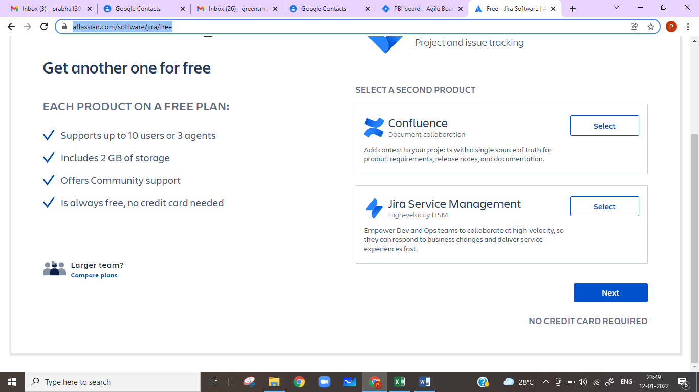

Step 4 : Click on “Continue with Google”

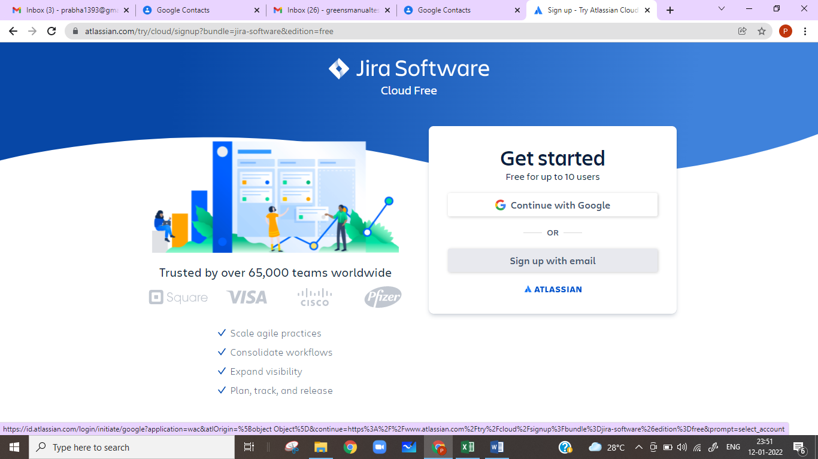

Step 5 : Provide the Newly created Gmail Account Credentials and Click on “Create your Account”

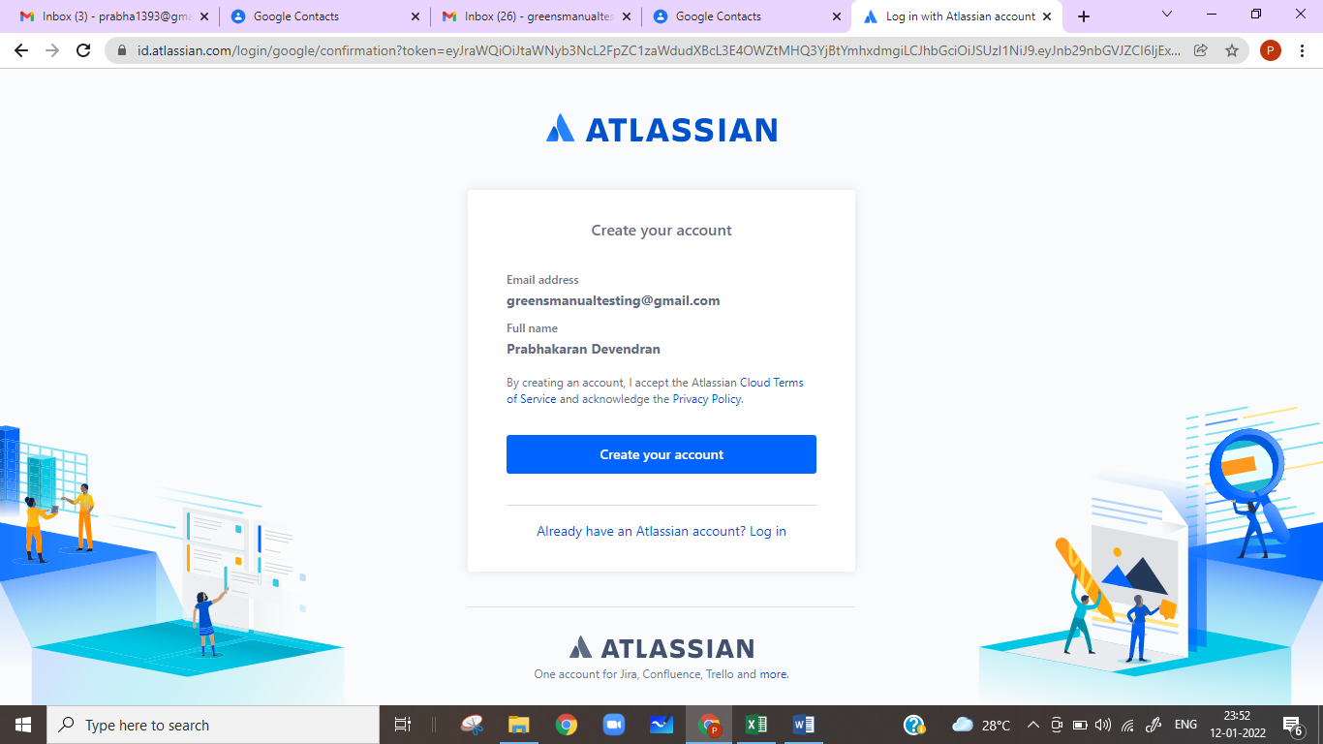

Step 6 : Provide a Unique Site name in “Your Site” Edit box until green tick appears as shown below and Click on “Agree” Button

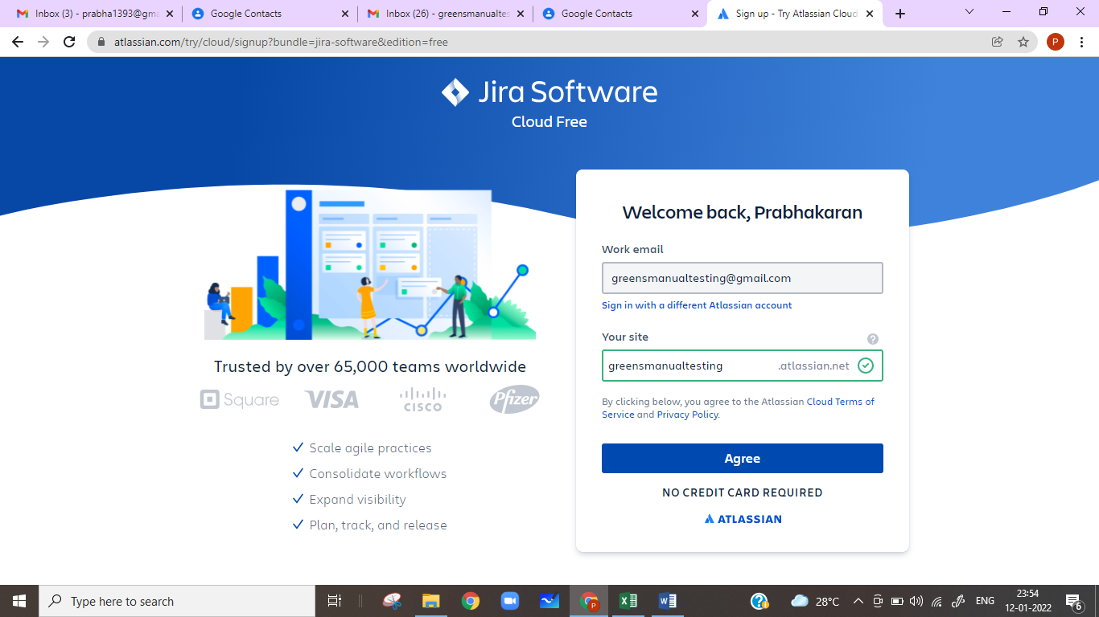

Step 7 : If the below page appears – Select “Software Development”

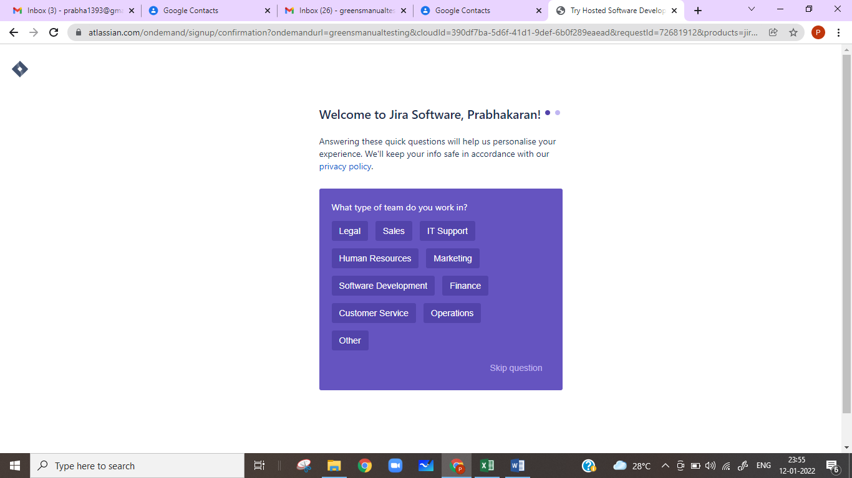

Step 8 : If the below page appears – Select “QA Engineer”

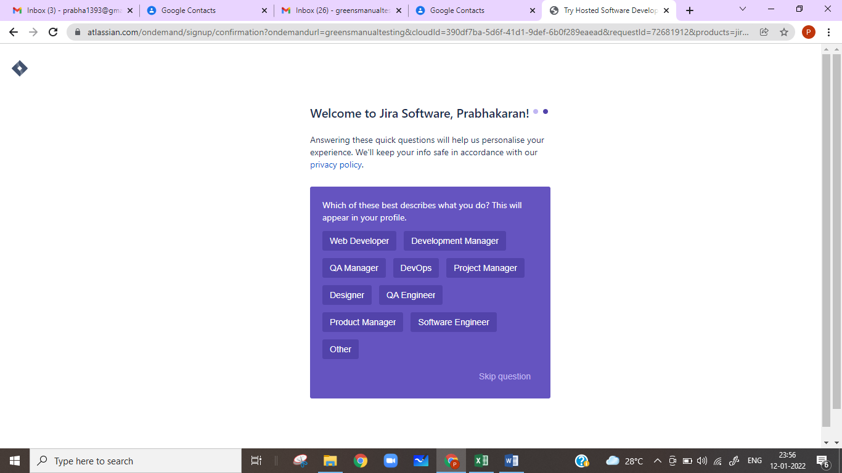

Step 9 : If the below page appears – Select “Skip” Button

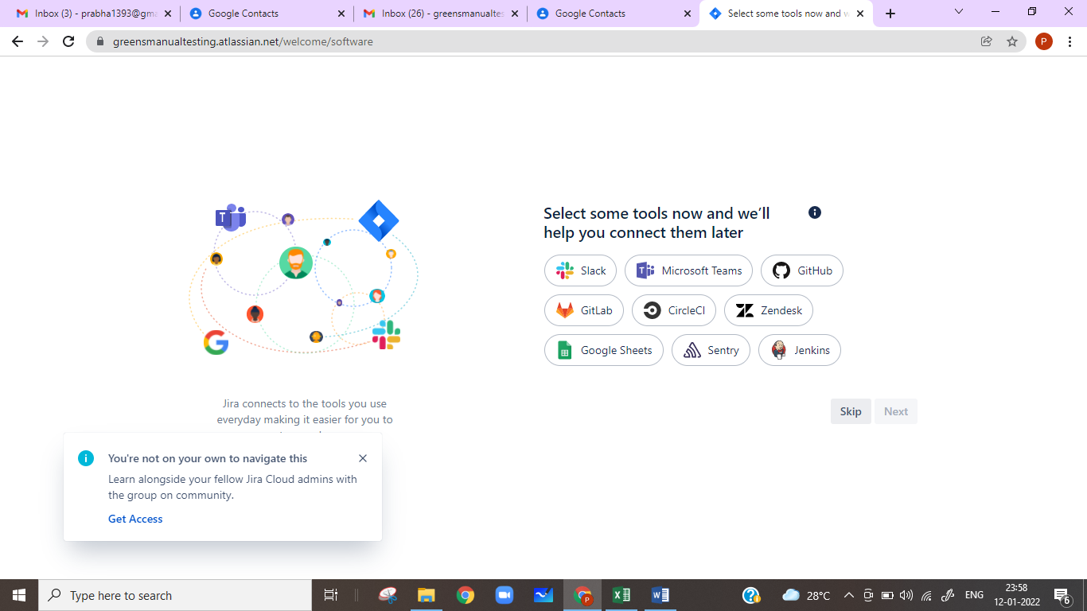

Step 10 : If the below page appears – Select “Continue” Button without giving any values

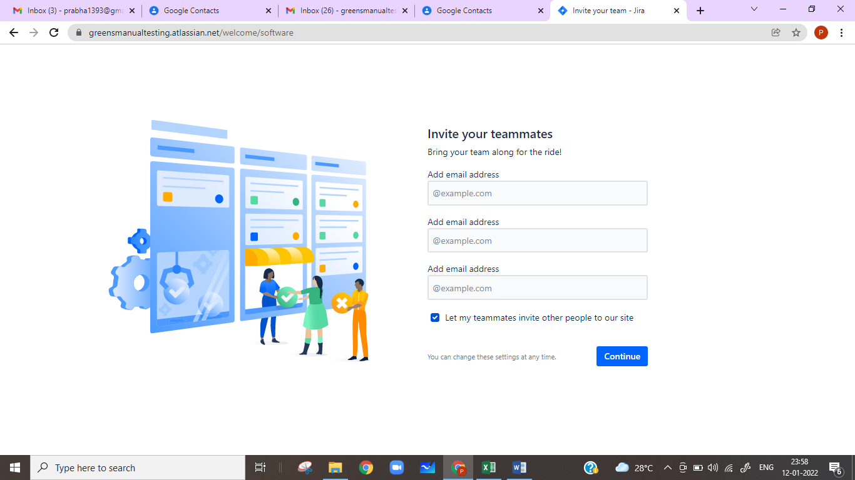

Step 11 : If the below page appears – Select “Skip” Button without giving any values

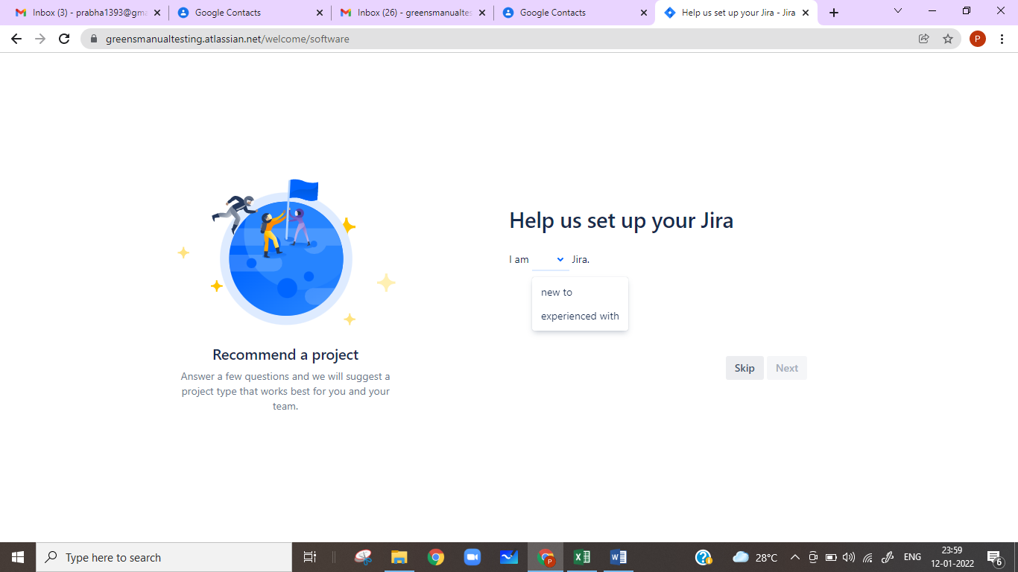

Step 12 : Click on “Scrum”

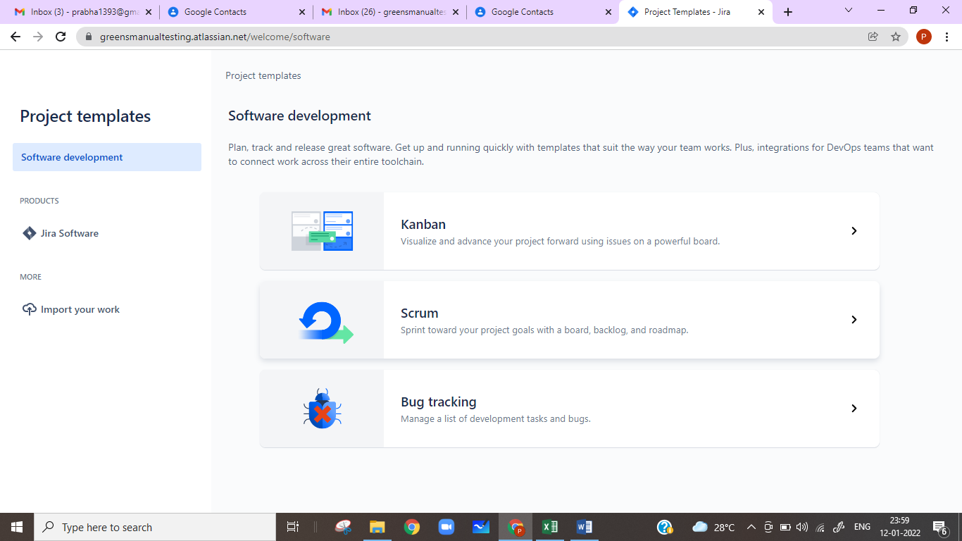

Step 13 : Click on “Use Template” button for the Scrum

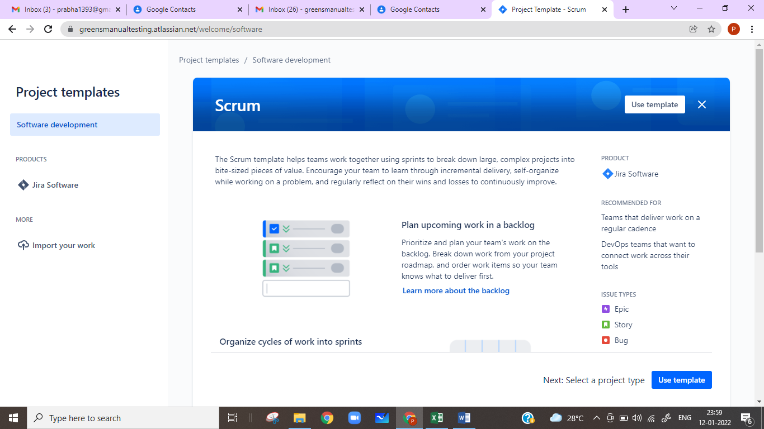

Step 14 : Click on “Select a Company-Managed Project” button

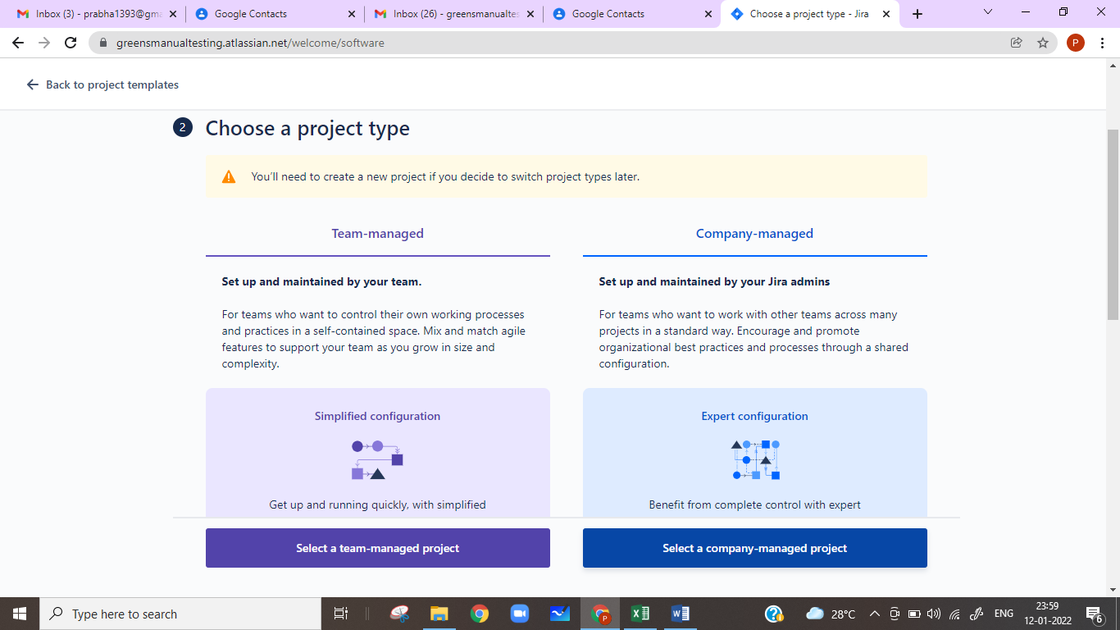

Step 15 : Enter “Policy Bazaar Insurance” in Name (Project) field and click on “Create Project” Button

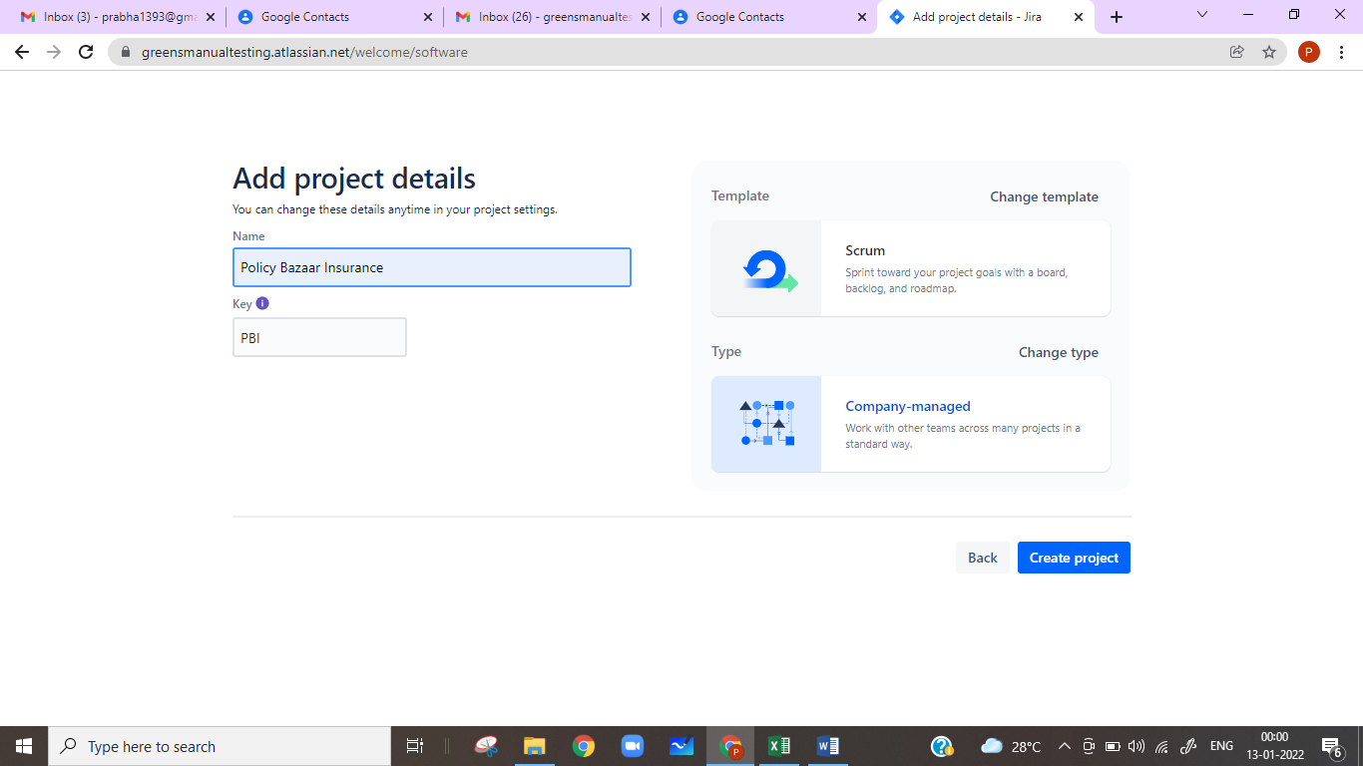

Step 16 : JIRA Project is created and Homepage should be visible

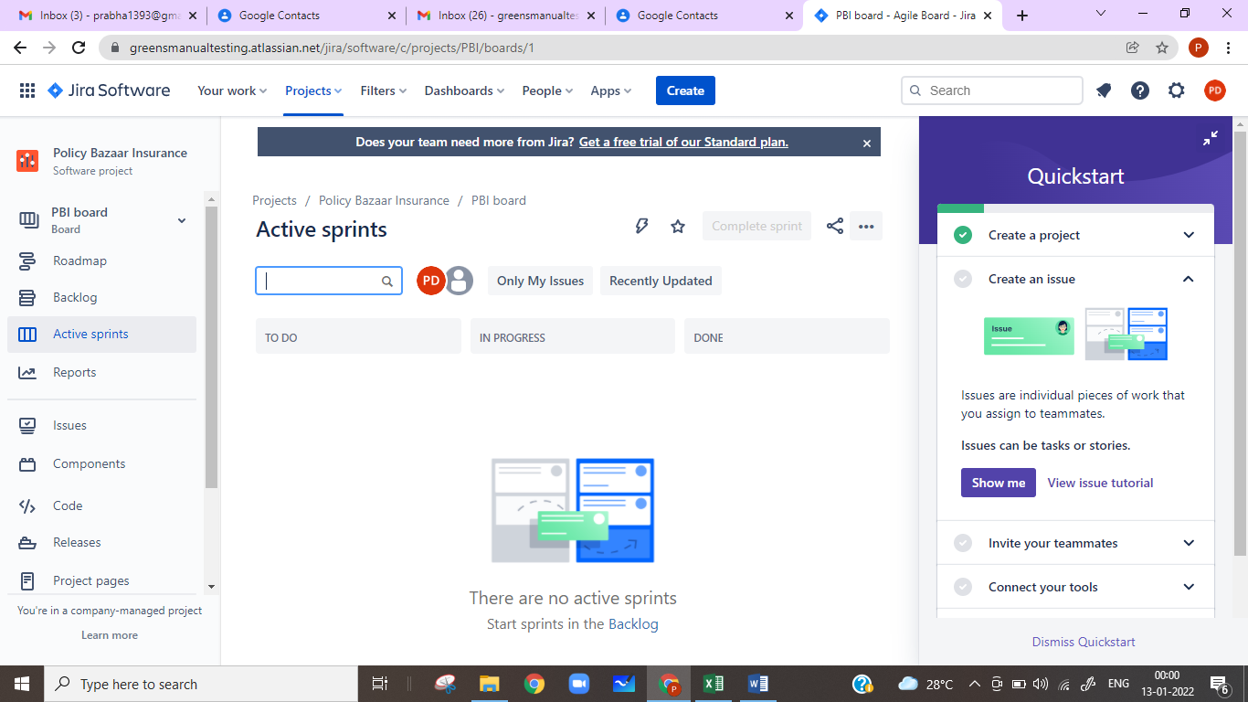

How to Create User Story in JIRA:

Step 1 : Click on “Create” Button on Top Centre of JIRA Homepage

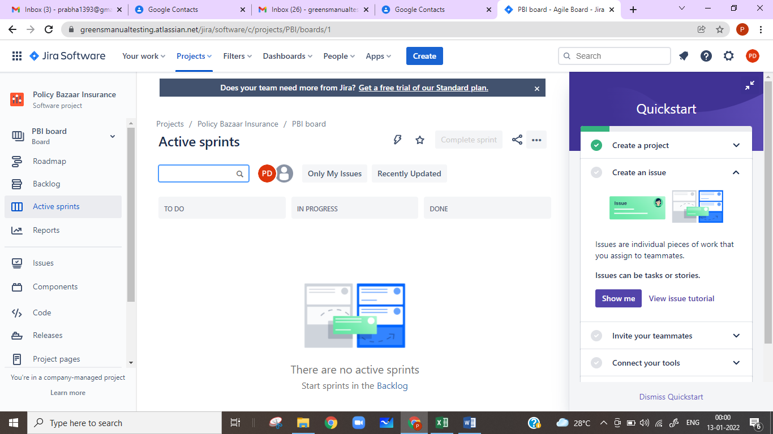

Step 2 :

* Select “Story” in Issue type
* Enter “Home Insurance Enquiry” in Summary
* Copy and Paste contents of PBI-1.txt in “Description
* Click on Create Button

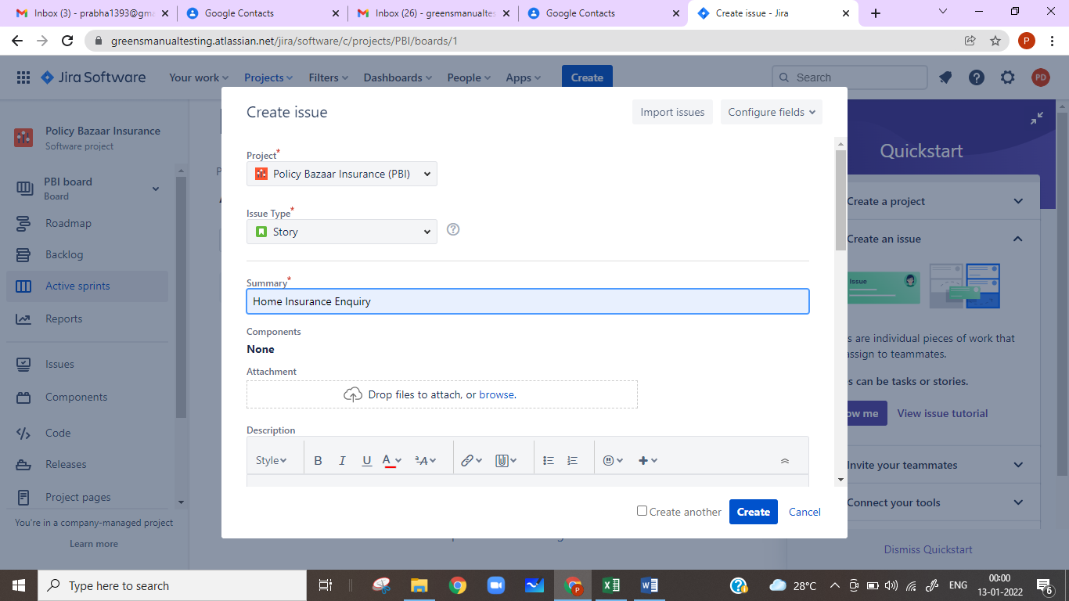

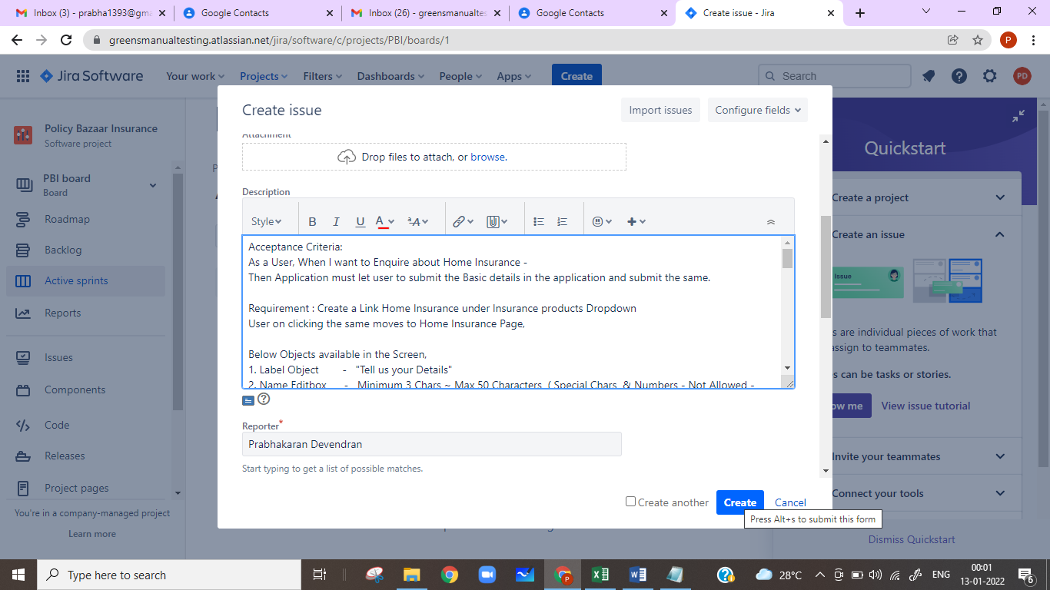

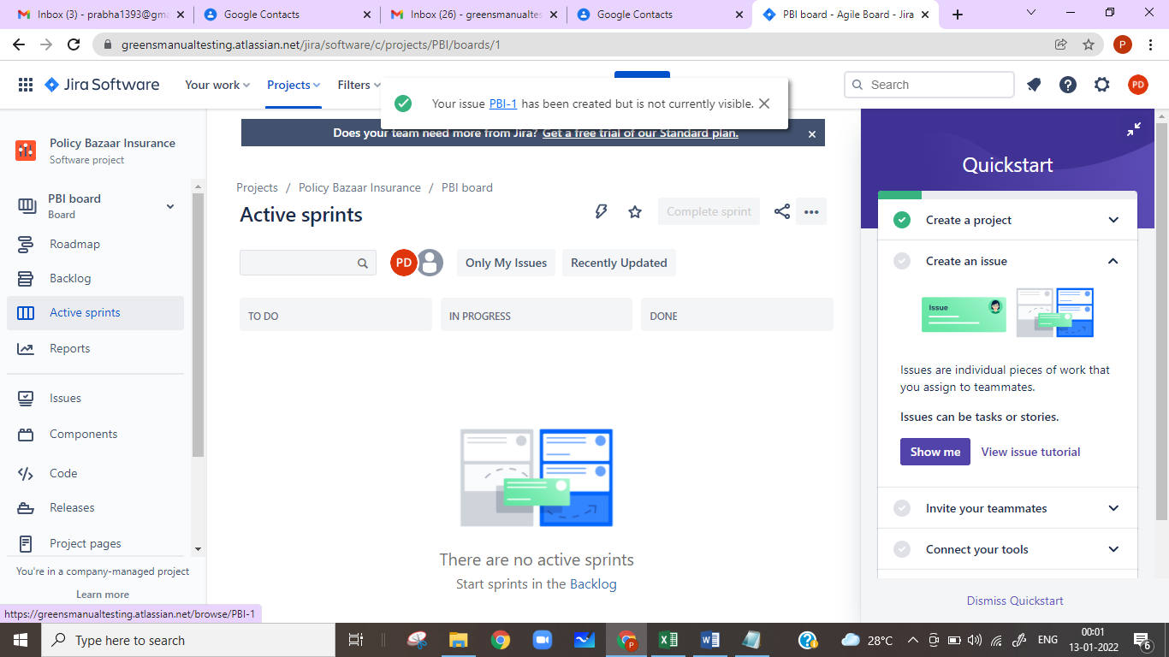

Step 3 : Use “Search” Edit box to view the User story

